**Set of 202 training datasets**

**Cluster 13**

**Cluster *i***

**Cluster 1**

**Statistical & Information-theoretic meta-feature clustering**

**General meta-feature clustering**

**Sub-cluster *j* of cluster 1**

**Sub-cluster 1 of cluster 1**

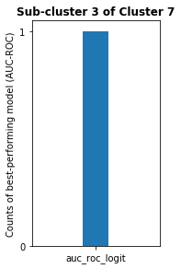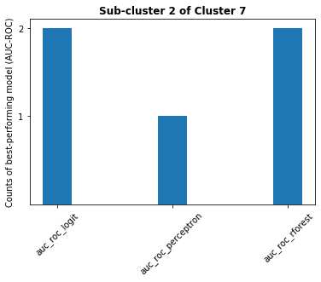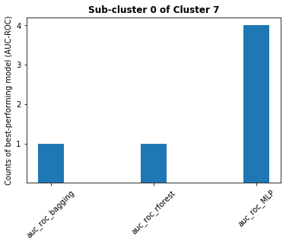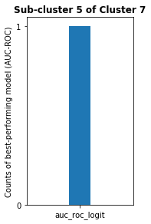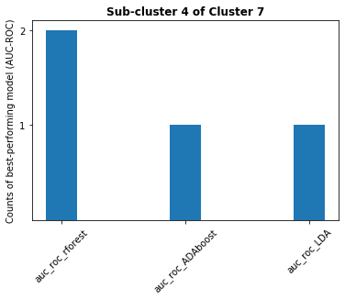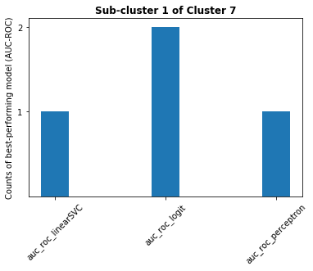

**Sub-clusters of**

**cluster 7**

**Cluster 7**